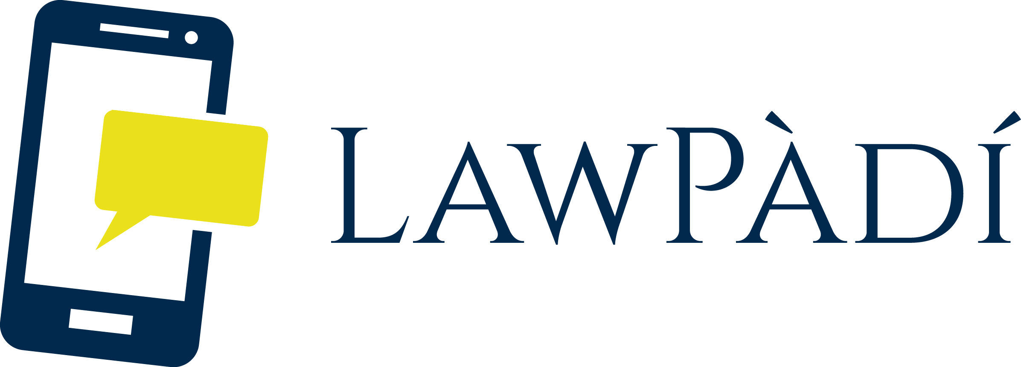

BLOG WEBSITE TERMS OF USE TOOLKIT

DISCLAIMER

LawPàdí is not a law firm. The information contained in this document is general legal information and should not be construed as legal advice to be applied to any specific factual situation. The use of this document template does not create or constitute an attorney-client relationship between the user of this template and LawPàdí, its employees or any other person associated with LawPàdí. You should not rely upon the information contained herein without first consulting an attorney with respect to your specific situation. This template is provided "As-Is," without warranty or condition of any kind whatsoever. LawPàdí does not warrant the template's quality, accuracy, timeliness, completeness, merchantability or fitness for use or purpose. LawPàdí, its agents and officers, shall not be liable for any damages whatsoever (including compensatory, special, direct, incidental, indirect, consequential, punitive or any other damages) arising out of the use or the inability to use this template.

INSTRUCTIONS FOR COMPLETING THE DOCUMENT

- Read the disclaimer on the front page of the Blog Website Terms of Use Tool Kit in full.
- You will need to edit this template before use.
- We have provided guidance notes to help you understand the document and assist you in using it. DELETE ALL BRACKETS AND HIGHLIGHTS after editing.
- Review the template to make sure you are comfortable with the terms, and that these are appropriate for your needs. Ideally you should speak to a qualified lawyer to ensure this is the case.
- You may be able to get free legal guidance using our public Q&A system, available at: www.lawpadi.com/questions

This toolkit is created by www.lawpadi.com and is licensed under the Creative Commons Attribution 4.0 International License. To view a copy of this license, visit http://creativecommons.org/licenses/by/4.0/

Terms of Use
PLEASE READ THESE TERMS CAREFULLY BEFORE ACCESSING THIS BLOG WEBSITE. USING THE WEBSITE INDICATES THAT YOU ACCEPT THESE TERMS. IF YOU DO NOT ACCEPT THESE TERMS, DO NOT USE THE WEBSITE.

Access and Use

- Use of the Website is free of charge. However, [Insert Blog Name] may, in our sole discretion, refuse access to any person or entity at any time.

- By accessing any part of the Website, you shall be deemed to have accepted this legal notice in full. If you do not accept this legal notice in full, you must leave the Website immediately.

- Certain features such as posting comments may require you to register for an account. You must provide accurate and complete information and keep your account information updated. You shall not:

- select or use as a username a name of another person with the intent to impersonate that person;
- use as a username a name subject to any rights of a person other than you without appropriate authorization; or
- use, as a username, a name that is otherwise offensive, vulgar or obscene.

- You are solely responsible for the activity that occurs on your account, and for keeping your account password secure. You may never use another person's user account or registration information without permission.

- You are prohibited from posting or transmitting to or from the Website any material: –

- that is threatening, defamatory, obscene, indecent, seditious, offensive, pornographic, abusive, liable to incite racial hatred, discriminatory, menacing, scandalous, inflammatory, blasphemous, in breach of confidence, in breach of privacy; or for which you have not obtained all necessary licences and/or approvals; or

- which constitutes or encourages conduct that would be considered a criminal offence, give rise to civil liability, or otherwise be contrary to the law of or infringe the rights of any third party, in any country in the world; or

- which is technically harmful (including, without limitation, computer viruses, Trojan horses, worms, harmful components, corrupted data or other malicious software or harmful data)

- which constitutes unsolicited advertising

Modifications

- [Insert Blog Name] may revise this legal notice at any time by updating this posting. You should check the Website from time to time to review the then current legal notice, because it is binding on you. Certain provisions of this legal notice may be superseded by expressly designated legal notices or terms located on particular pages at the Website.

Third Party Links

- Links to third party websites on the Website are provided solely for your convenience. If you use these links, you leave the Website. [Insert Blog Name] therefore does not endorse or make any representations about them, or any material found there, or any results that may be obtained from using them. If you decide to access any of the third party websites linked to the Website, you do so entirely at your own risk.

- If you would like to link to the Website, you may only do so on the basis that you link to, but do not replicate, the home page of the Website, and subject to the following conditions:

- you do not remove, distort or otherwise alter the size or appearance of our logo or any other logos that may appear;
- you do not create a frame or any other browser or border environment around the Website;
- you do not in any way imply that [Insert Blog name], its owners or its affiliates are endorsing any products or services other than their own;
- you do not misrepresent your relationship with [Insert Blog Name] nor present any other false information about [Insert Blog Name], its owners, or its affiliates.
- you do not otherwise use any trade marks displayed on the Website without express written permission from [Insert Blog Name]
- your website does not contain content that is distasteful, offensive or controversial, infringes any intellectual property rights or other rights of any other person or otherwise does not comply with all applicable laws and regulations.

Content

- For purposes of this Terms of Use, the term "Content" includes, without limitation, information, data, text, photographs, videos, audio clips, written posts, articles, comments, software, scripts, graphics, and interactive features generated, provided, or otherwise made accessible on our Blog. For the purposes of this Agreement, "Content" also includes all User Content (as defined below).

- All Content added, created, uploaded, submitted, distributed, or posted to the Blog by users (collectively "User Content"), whether publicly posted or privately transmitted, is the sole responsibility of the person who originated such User Content. You represent that all User Content provided by you is accurate, complete, up-to-date, and in compliance with all applicable laws, rules and regulations.

- We reserve the right to, but do not have any obligation to, remove, edit, modify or otherwise manipulate any Content in our sole discretion, at any time, without notice to you and for any reason.

Intellectual Property Rights

- Unless otherwise stated, the copyright and other intellectual property rights in all material on the Website (including without limitation photographs and graphical images) are owned by [Insert Blog Name] or its owners.

- By submitting User Content on this Blog, you hereby do and shall grant us a worldwide, non-exclusive, perpetual, royalty-free, sub-licensable and transferable license to use, edit, modify, aggregate, reproduce, distribute, prepare derivative works of, display, perform, and otherwise fully exploit the User Content in connection with the Blog and our (and our successors' and assigns') businesses, including without limitation for promoting and redistributing part or all of the Blog (and derivative works thereof) in any media formats and through any media, and including after your termination of your Account (if any Account is created)

Limitation of Liability and Indemnification

- THE CONTENT ON THIS BLOG IS PROVIDED "AS IS", "AS AVAILABLE" AND WITHOUT WARRANTY OF ANY KIND, EXPRESS OR IMPLIED, INCLUDING, BUT NOT LIMITED TO, THE IMPLIED WARRANTIES OF TITLE, NON-INFRINGEMENT, MERCHANTABILITY AND FITNESS FOR A PARTICULAR PURPOSE, AND ANY WARRANTIES IMPLIED BY ANY COURSE OF PERFORMANCE OR USAGE OF TRADE, ALL OF WHICH ARE EXPRESSLY DISCLAIMED. WE, AND OUR DIRECTORS, EMPLOYEES, AGENTS, SUPPLIERS, PARTNERS AND CONTENT PROVIDERS DO NOT WARRANT THAT: (I) THE SERVICES WILL BE SECURE OR AVAILABLE AT ANY PARTICULAR TIME OR LOCATION; (II) ANY DEFECTS OR ERRORS WILL BE CORRECTED; (III) ANY CONTENT OR SOFTWARE AVAILABLE AT OR THROUGH THE SERVICES IS FREE OF VIRUSES OR OTHER HARMFUL COMPONENTS; OR (IV) THE RESULTS OF ACCESSING THIS WEBSITE IS SOLELY AT YOUR OWN RISK.

- [INSERT BLOG NAME] ITS OWNERS, ANY OTHER PARTY (WHETHER OR NOT INVOLVED IN CREATING, PRODUCING, MAINTAINING OR DELIVERING THE WEBSITE), AND ANY OTHER TRADING NAMES, MEMBERS, EMPLOYEES, CONSULTANTS OR AGENTS OF ANY OF THE AFOREMENTIONED, EXCLUDE ALL LIABILITY AND RESPONSIBILITY FOR ANY AMOUNT OR KIND OF LOSS OR DAMAGE THAT MAY RESULT TO YOU OR A THIRD PARTY (INCLUDING WITHOUT LIMITATION, ANY DIRECT, INDIRECT, PUNITIVE OR CONSEQUENTIAL LOSS OR DAMAGES, OR ANY LOSS OF INCOME, PROFITS, GOODWILL, DATA, CONTRACTS, USE OF MONEY, OR LOSS OR DAMAGES ARISING FROM OR CONNECTED IN ANY WAY TO BUSINESS INTERRUPTION, AND WHETHER IN TORT (INCLUDING WITHOUT LIMITATION NEGLIGENCE), CONTRACT OR OTHERWISE) IN CONNECTION WITH THE WEBSITE IN ANY WAY OR IN CONNECTION WITH THE USE, INABILITY TO USE OR THE RESULTS OF USE OF THE WEBSITE

- You acknowledge that all Content, including User Content, accessed by you is at your own risk and you will be solely responsible for any damage or loss to you or any other party resulting therefrom.

Nigerian Cybercrime Act 2015 Specific Provisions

- [Insert Blog Name] reminds its users of the importance of adherence to the provisions of the Cybercrime Act 2015, specifically Sections 23, 24 and 26. [Insert Blog Name] will not hesitate to report any users who breach these provisions, and will provide all necessary information to the necessary authorities as required in the case of any alleged breach.

Dispute Resolution

- This legal notice shall be governed by and construed in accordance with Nigerian law. Disputes arising in connection with this legal notice shall be subject to the exclusive jurisdiction of the Nigerian courts.

Miscellaneous

- The section and paragraph headings in this User Agreement are for convenience only and shall not affect their interpretation.

- This document is the entire agreement between you and us with respect to the use of this Blog. If any provision of this User Agreement is found to be unenforceable or invalid, that provision will be limited or eliminated to the minimum extent necessary so that this User Agreement will otherwise remain in full force and effect and enforceable.

- You may contact us at [Insert Contact Email/Phone Number]

- Effective Date of User Agreement: [Insert the Date you Upload this document]

